****Whitkirk Primary School

Relationships and Regulation Policy

*‘Be the best that we can be’*

|  |  |
| --- | --- |
| Created/ revised & approved by staff | July 2024 |
| Ratified by governors | July 2024 |
| Next review date | July 2026 |

# Policy Statement- ‘The Whitkirk Way’:

Whitkirk Primary School has high expectations of behaviour. We focus on building positive relationships between children, staff, parents/carers and the wider community.

We recognise understanding our emotions is a key aspect of managing behaviour successfully. Children need to be taught how to regulate their sensory needs, emotions, energy and impulses to meet the demands of their environment e.g. school, reach their goals and have a sense of well-being. This policy aims to support children in learning these essential life skills. Through the strategies outlined in this policy, we aim for both adults and children to understand and regulate their own behaviour, creating a secure environment that is conducive to learning.

Underpinning this Relationships and Regulation policy is the belief that everyone can learn to self-manage and regulate their own emotions and behaviour. Therefore, we encourage reflective thinking and restorative approaches. Ultimately, we wish to give our children confidence about their capacity to think for themselves and to make sense of their own lives and experiences into the world beyond the school gates.

This policy is for all staff, pupils, parents/carers, governors, visitors and partner agencies working within the school and provides guidelines and procedures as to how our school supports and responds to behaviour.

## Policy Aims and Objectives

Whitkirk Primary School is committed to the emotional mental health and well-being of its staff, pupils and parents/carers. We work towards this in all aspects of school life, providing an ethos, environment and curriculum which promotes, teaches and supports emotional regulation and positive mental health of the whole school community.

It is acknowledged that members of the school community may have very different lived experiences and views on behaviour. However, the aim of our Relationship and Regulation policy is to bring us all together to adhere to some basic principles and practices that reflect our school ethos and values.

Whitkirk Primary School treats all children with unconditional respect, positive kind regard and has high expectations for both adults’ and children’s learning and social behaviours. Our school is safe and compassionate. It prides itself on excellent relationships and a high level of care. We understand all behaviour is communication and we need to work together to support the needs of our young people and their families.

The vision for managing behaviour successfully at Whitkirk is in line with our core values:

* **Achievement** – we always try our best. We help maintain a happy, caring, safe community in which effective learning can take place and where there is mutual respect between all.
* **Safety** – we take care of our resources and move around school safely. We help all staff, children and families become emotionally aware and, through restorative approaches, repair harm and restore relationships.
* **Respect** – we respect each other and value others’ opinions. We help children to develop a sense of worth, identity in themselves and others.
* **Friendship** – we actively listen to our friends, family and teachers. We help develop in all children the ability to listen to others; cooperate and to appreciate other ways of thinking and behaving.
* **Trust** – we are always honest with ourselves and others
* **Forgiveness** – we forgive ourselves and others for mistakes that are made

At Whitkirk, we work to achieve each of these school values in all that we do and strive to be ‘**the best that we can be’**.

# Eight Key Areas to Whitkirk’s Relationship and Regulation Policy

1. Building and maintaining positive relationships
2. Three simple expectations
3. Consistent use of language
4. Positive recognition
5. Curriculum offer
6. Emotional Coaching
7. Restorative and problem-solving approaches
8. Graduated response

### Building and Promoting Positive Relationships

Building and maintaining trusting relationships with children and each other is an expectation for all staff at Whitkirk. Our leaders are pro-active, present and put well-being at the forefront of decision making. Our policy is underpinned by reflective practice opportunities.

Positive home-school relationships

At Whitkirk, we pride ourselves on developing strong and supportive relationships with children and their parents/carers. Our processes of communicating with parents/carers facilitates two-way through being proactive and positive.

We use the following approaches to building positive relationships in school:

* Daily Meet and Greet for children and parents/carers
* Corridor kindness (being noticed)
* Clear routines and expectations in class and school (including transitions & lining up)
* Visual Timetables in class and individual (where required)
* Comprehensive recruitment and induction process for new staff and pupils.
* Thorough transition processes for new pupils during/start of the year
* Use of consistent, positive language, actions and keeping calm.
* Acknowledgement and validation of feelings through emotional coaching
* An emphasis on relational repair through restorative approaches
* An ethos where mutual respect for all is an expectation.

### Three Simple Expectations

At Whitkirk, children follow three simple expectations when learning.

* Ready
* Respectful
* Safe

All members of staff will hold up three fingers and say, “Three, two, one, ready to… (state the instruction)”. All children are then expected to show all members of staff our school value of respect and follow the instruction given. We understand that the children show they are ready will differ for some children and all members of staff will be aware of this e.g. use of fidget toys, looking elsewhere in the room and will be written on their individual provision maps.

The school expectations are discussed with children regularly in class and are displayed in every classroom and across school.

When dealing with any inappropriate incidents, it is important to refer to the school value that has not been adhered to. Similarly, when acknowledging a positive action or response it is important to also refer to the school expectation or core value that has been demonstrated, to further develop children’s understanding and knowledge of these.

For low level behaviours, which do not pose a health and safety risk to adults or children, we will follow the process below:

**Reminder** – A reminder of the Whitkirk value. This is delivered privately if possible. Repeat reminders if reasonable adjustments are necessary.

**Stop and think**- Give children time to reflect and self-regulate or change behaviours. The aim should be to avoid any escalation, and if this takes a longer time than usual, this is advised.

**Consequence and Repair** – When the child is completely calm and self-regulated, a quick restorative conversation at an appropriate time and place will be initiated (see Appendix 3 for further details) A fair consequence may be agreed. This may include discussing the behaviours with parents/carers to support/ follow this up at home.

**Formal Discussion –** If the child finds it difficult to improve their behaviours and make appropriate choices, a senior leader will become involved, and Parents/carers notified. Parents/carers may take part in the discussion if deemed appropriate. The Phase Leader will be the senior person in the first instance, then Assistant Headteachers or Deputy Headteacher and then the Headteacher, if deemed more serious. The Repair step may be revisited here, and more serious consequences agreed. Where formal discussions are becoming frequent, the Graduated Response section of the policy will be followed. (Appendix 8)

### Consistency of Language

Through the systems we have here at Whitkirk, language used across the school is consistent when dealing with poor or dysregulated behaviour. This also includes body language as well as use of voice.

Adult Language (including body language and use of voice):

* We are careful what we say and how we say it; we are respectful and non judgemental.
* We use positive language that supports learning, saying what should be done rather than what shouldn’t (e.g. walk down the corridor rather than stop running)
* Our voices remain calm and in control and language is kept to a minimum when a child is in fight or flight.
* Adults are aware of their body language and use appropriate non-verbal cues.
* Language focuses on the feeling not the behaviour and empathy towards a child is shown.
* Our language engages pupils in learning about the effects of their actions, making sure the reason for a decision is always understood.
* We set clear expectations for the future and restorative approaches are used to help pupils understand the effect of their actions and the importance of taking responsibility to make things right.

### Positive Recognition

This policy promotes the understanding people should do positive things for the good of themselves and others and not just for the reward itself.

At Whitkirk, the following strategies or responses are implemented consistently across school to promote a positive approach to managing emotional regulation as well as developing and maintaining healthy, strong relationships.

Positive reinforcement takes place in the following ways;

* Acknowledgment of ‘expected’ behaviour and actions through positive praise.
* Proud Postcards
* Star of the Week
* Class Dojo Points
* Child visiting the Leadership Team to celebrate above and beyond behaviour
* Weekly Celebration Assemblies

**Postcards**

*Proud postcards-* When children have displayed exemplary behaviour, effort or skill, the class teacher will send a postcard home to Parents/carers.

*Diamond postcards-* Each half-term, one child from each class will be sent home a diamond postcard for outstanding learning and behaviour across the half term and be invited to an afternoon tea one afternoon.

*Platinum postcards-* Each half-term, one child from each class will be sent home a platinum postcard from the Headteacher and Deputy Headteacher exceptional learning and behaviour across the half term and be invited to a pizza party.

**Class Challenge**

Every few weeks, the Class Teacher will set a ‘secret’ challenge for their class linked with the school’s value e.g. using please and thankful with the aim that other children and staff take notice and report back to the Class Teacher.

**Class Dojo Champion**

Each week, the child in each class who has received the most Class Dojo points for following our school values will be celebrated with a certificate and awarded a team point in Celebration Assembly.

**Star of the week**

Each week, we nominate two children from each class to be part of our ‘Stars of the Week’ which celebrates effort or achievement in both behaviour and/or their work. These nominations are recognised with the award of certificates in our celebration assembly.

### Curriculum Offer

At Whitkirk, we believe children should learn to take responsibility for their own actions by empowering them to understand themselves and others. Our curriculum offer is designed to support this by teaching the children to:

* Learn about themselves and recognise their own emotions.
* Develop a wider understanding of emotional vocabulary to describe how they feel.
* Recognise how their emotions can affect their own behaviour and that of others.
* Recognise that their behaviour can impact on the feelings of others.
* Express their emotions appropriately through socially ‘expected’ behaviours
* Develop lifelong regulation skills through developing their own ‘tool boxes’.
* Take responsibility for their own actions and begin to independently problem solve when relationships need repair.
* Recognise emotions in others, developing empathy, confidence and the skills to support others when they are emotionally dysregulated.
* Understand how to build and maintain strong, healthy relationships

Although many of the points above are woven through our interactions every day, we also specifically teach them through:

* + Our PSHE lessons (see PSHE policy)
  + Zones of Regulation (see Appendix 4)
  + Picture News sessions
  + Emotional regulation strategies (see below and also Appendix 5)

### Emotional Regulation Strategies

When dealing with ‘unexpected’ or inappropriate behaviour that is clearly due to an emotion, staff will use the strategies below to address the situation. Emotional regulation teaching is all about:

* Teaching the child ‘in the moment’ about the world of emotion.
* Supporting the development of strategies to deal with emotional ups and downs.
* Accepting all emotions as normal and valid.
* Using moments of both negative and positive behaviour as opportunities for teaching and reflecting.
* Building trusting and respectful relationships.

Staff will use the 4-step approach:

Step 1- Notice and empathise

Step 2- Name and validate it

Step 3- Set boundaries and expectations

Step 4- Problem solve and learn

If a child is in an emotionally heighted state, the member of staff may need to give the child time to regulate before beginning to emotionally coach. This enables the strategy to be more successful as the child will be in an emotional state for learning to take part.

An Emotional Coaching prompt card can be found in Appendix 5

### Restorative and Problem-Solving Approaches

Restorative approaches have been found very effective in improving behaviour and attitude as it promotes telling the truth, taking responsibility, acknowledging harm as appropriate response to conflict and in doing so creates accountability and brings about the understanding of the need to restore the relationship that has been damaged by the behaviour.

* Poor behaviour choices will be revisited in order for the child to learn what went wrong and how to deal with it more appropriately next time. This is often done as a restorative conversation.
* Limit setting and problem solving can follow sometime after an event, when the pupil is regulated and able to reflect upon their behaviour. In such circumstances, staff should inform the pupil that their behaviour is inappropriate and that it will be spoken about later using restorative approach to support them to consider alternative approaches.
* A consequence may simply be a 2-minute conversation at the end of a lesson. The consequence must be relevant to the issue, repair any relational damage and ensure learning has taken place regarding what went wrong.
* Consequences will never involve taking away a previously earned privilege or any intervention time. However, if behaviour has been too extreme to access that privilege or intervention at that time we would encourage the pupil to access that particular reward at a subsequent date.
* Staff will avoid any consequences which lead to unnecessary shaming or humiliation of the pupil. We understand that such approaches are detrimental to the pupil’s self- esteem and wellbeing, and can result in increased inappropriate behaviour.
* The developmental age and specific needs of the pupil will be considered when deciding appropriate consequences. We recognise that a ‘one size fits all’ approach is not appropriate for our pupils.
* After a pupil completes catch up, reflection time, or a consequence it is important to repair and restore the staff-pupil relationship. Staff should praise his or her behaviour at the first opportunity to reduce the attention away from the inappropriate behaviour. Staff must reassure the pupil that the inappropriate behaviour has been dealt with and that all parties will move on and start afresh. Unconditional positive regard is to be maintained.
* In addition to consequences pupils will be supported to reflect on their behaviour and be given an opportunity to problem solve for example they may be supported to repair the relationship, replace something that has been broken or tidy a classroom that has been disrupted.
* Contact may be made with Parents/carers to identify any possible causes of difficulties, for example a change in circumstances at home.

# Graduated Response

For the majority of children, inappropriate behaviour will be dealt with using the processes as described above in this policy. However, for some individuals this system may not be effective as a consequence of their individual needs or circumstances.

For this minority of pupils, tailored individual emotional regulation plans will be established as part of a graduated response. These will be coordinated by Afua Downes (Assistant Headteacher-SENCO) or Sarah Hart (Lead Learning Mentor & DSL) and will reflect the young person’s needs as well as an agreed set of approaches to support them to regulate themselves appropriately. The use of external agencies for additional professional advice and support will also be encouraged such as MindMate, SENIT and the East Area Inclusion Team.

Where appropriate an individual risk assessment will also be completed to safeguard the pupil, their peers and the adults supporting the individual. Parents/carers will be involved in the writing, and review of these documents. These will be reviewed and adapted as necessary to ensure they are safe to implement for staff and children and reflect any changes in circumstances during this period (See Appendix 9)

# Bullying

**Bullying** is defined as the repetitive, intentional harming of one person or group by another person or group, where the relationship involves an imbalance of power.

Bullying is, therefore:

* Deliberately hurtful
* Repeated, often over a period of time
* Difficult to defend against

Bullying can include:

|  |  |
| --- | --- |
| **Type of bullying** | **Definition** |
| Emotional | Being unfriendly, excluding, tormenting |
| Physical | Hitting, kicking, pushing, taking another’s belongings, any use of violence |
| Racial | Racial taunts, graffiti, gestures |
| Sexual | Explicit sexual remarks, display of sexual material, sexual gestures, unwanted physical attention, comments about sexual reputation or performance, or inappropriate touching |
| Direct or indirect verbal | Name-calling, sarcasm, spreading rumours, teasing |
| Cyber-bullying | Bullying that takes place online, such as through social networking sites, messaging apps or gaming sites |

Details of our school’s approach to preventing and addressing bullying are set out in our anti-bullying policy which is available on the school website.

# Child on Child Sexual violence and Sexual Harassment

Whitkirk Primary School has a zero-tolerance approach to sexual violence and sexual harassment; it is never acceptable, and it will not be tolerated. When referring to sexual harassment this means ‘unwanted conduct of a sexual nature’ that can occur online and offline and both inside and outside of school.

All staff are trained to never pass sexual harassment as “banter”, “just having a laugh”, “a part of growing up” or “boys being boys”. Reports of sexual violence and sexual harassment are likely to be complex and require difficult professional decisions to be made, often quickly and under pressure. Decisions and appropriate sanctions will be made on a case-by-case basis, with the designated safeguarding lead (DSL) (or deputy) taking a leading role and using their professional judgement, supported by the senior leadership team and other agencies, such as children’s social care and the police, as required.

# Physical Intervention

Although every opportunity will be taken to diffuse a situation and support pupils to regulate there will be occasions when pupils lose control and a physical intervention may be necessary to keep themselves and others safe. There are named staff at Whitkirk Primary who are certified in ‘Team Teach’. All staff follow the policy and procedures for Physical Intervention (referred to as the Physical Intervention Policy).

Parents/carers will be informed if their child is involved in a significant incident. Please refer to the Department for Education (DfE) document “Use of Reasonable Force in Schools.” Physical intervention must be recorded on a separate Physical Intervention form and handed to the Headteacher, as well as recorded on CPOMS (online monitoring system). A meeting will be held with the staff member involved in the physical intervention and Assistant Headteacher to discuss the intervention and debrief. It is important that, at an appropriate point, the member of staff initiating the intervention meets with the young person to debrief, discuss the need for the intervention and, most importantly, restore the relationship.

# Recording behaviour

Whitkirk monitor pupils behaviour and record incidents, including Physical Intervention, using the electronic system CPOMS. Where there have been issues regarding behaviour, staff must record this on CPOMS, ensuring they detail what the outcome was as well as the incident itself and any communication with relevant staff and parents/carers where appropriate.

# Confiscation

Searching and screening pupils is conducted in line with the DfE’s [latest guidance on searching, screening and confiscation](https://www.gov.uk/government/publications/searching-screening-and-confiscation).

Any prohibited items found in pupils’ possession will be confiscatedandwe will also confiscate any item which is harmful or detrimental to school discipline. These items will be returned to pupils after discussion with senior leaders and parents/carers, if appropriate. **Staff authorised by the Headteacher to search or screen a pupil without consent are: The Headteacher, Deputy Headteacher, Assistant Headteachers, Phase Leaders and Learning Mentors. Searches will always take place with two members of staff present.**

School Leaders and school staff (two members of staff present) can search a pupil for any item if the pupil agrees.

The Headteacher and staff authorised by them to have the statutory power to search pupils and their possessions, can search a pupil without consent where they have reasonable grounds for suspecting that the pupil may have a prohibited item. Prohibited items in our school are:

* weapons
* alcohol or illegal drugs
* stolen goods
* tobacco products, e.g. cigarettes
* pornographic images
* fireworks
* anything that has been, or is likely to be, used to cause injury or commit an offence

# Suspension/Permanent Exclusion

Owing to our inclusive ethos at Whitkirk, the decision to suspend or permanently exclude will be as a last resort. However, if a serious incident occurs where staff or children are put at risk, a consequence maybe that the child is unable to return to school for a fixed period of time (suspension) or in extreme circumstances, maybe subject to a permanent exclusion. Where a child has identified SEND, the school will make all reasonable adjustments to reduce the risk of exclusion or further exclusions.

The decision to suspend/permanently exclude is made by the Headteacher. Parents/carers will be informed, and this will be followed up in writing. The Headteacher will also inform other relevant personnel as appropriate, e.g. social worker, virtual headteacher, local authority, governing body and CEO of our Trust.

The decision letter will also inform the parent/carer of their duties, rights and other relevant information.

Work will be set for the pupil by the school for the first 5 days of suspension; this may include resources

from online sources. For a suspension of more than five school days, the governing

board/school must arrange suitable full-time education for any pupil of compulsory school age. This

provision is commonly called alternative provision and must begin no later than the sixth school day of the

suspension.

At Whitkirk, it is important that pupils who have been suspended are supported to reintegrate into

school life; in order to do this a meeting will be held with the pupil and their parent(s)/carer(s) before, or at

the beginning of the day when the pupil is due to return to school to discuss a way forward.

Statutory guidance from the DfE sets out what schools and local authorities must do to comply with

the law; information can be accessed here:

[Suspension and permanent exclusion guidance September 2023 (publishing.service.gov.uk)](https://assets.publishing.service.gov.uk/government/uploads/system/uploads/attachment_data/file/1181584/Suspension_and_permanent_exclusion_guidance_september_23.pdf)

# Behaviour and Safeguarding – mobile phones and technology

Children are not permitted to have mobile phones in school. We appreciate that some parents/carers of children who walk to and from school without parental supervision (Y5 & Y6), may want their child to carry a mobile phone for safety.

Any children who bring mobile phones to school must give them in to their teachers first thing in the morning and collect them at 3:15pm. They are not to be used in school. Mobile phones which are found in school will be taken to the main school office.

Devices such as iphone/smart watches - those that can make phone calls, take photos or record others are not permitted in school. If these are seen, teachers will ask the child to remove the device, and the teacher will return it to the child at the end of the day.

School accepts no responsibility for mobile phones/other devices in school. They are brought in at the owners/parents/carers risk.

Where there are concerns or allegations of youth generated sexual imagery, (often referred to as ‘sexting’) these must always be reported to the DSL, who will follow our Safeguarding and Child Protection Policy and make referrals to the Police and Children’s Social Care, where appropriate.

# Behaviour outside of School

At Whitkirk Primary School, we want to instill in our pupils a high standard of behaviour both in and out of school. As such, we will respond to poor behaviour or bullying which occurs off school premises or online and which is witnessed by a staff member or reported to the school in the following circumstances:

* when taking part in any school-organised or school-related activity;
* when travelling to or from school;
* when wearing school uniform;
* when in some other way identifiable as a pupil at the school;
* that could have repercussions for the orderly running of the school;
* that poses a threat to another pupil; or
* that could adversely affect the reputation of the school.

We will contact Parents/carers in these cases and will work with outside agencies where appropriate.

# Allegations made against staff

Allegations against staff will be investigated. Allegations of abuse will be investigated using the DfE document ‘Keeping Children Safe in Education September 2023’ and ‘RKLT Safeguarding and Child Protection Policy’ 2023/24.

If you have concerns about a member of staff (including a supply teacher or volunteer), or an allegation is made about a member of staff (including a supply teacher or volunteer) posing a risk of harm to children,

speak to the headteacher. If the concerns/allegations are about the headteacher, speak to the chair of

governors or Director of HR for the Red Kite Learning Trust or Local Authority Designated Officer (LADO).

# Legislation and statutory requirements:

This policy is based on advice from the Department for Education (DfE) on:

* [Behaviour and discipline in schools](https://www.gov.uk/government/publications/behaviour-and-discipline-in-schools)
* [Searching, screening and confiscation at school](https://www.gov.uk/government/publications/searching-screening-and-confiscation)
* [The Equality Act 2010](https://www.gov.uk/government/publications/equality-act-2010-advice-for-schools)
* [Use of reasonable force in schools](https://www.gov.uk/government/publications/use-of-reasonable-force-in-schools)
* [Supporting pupils with medical conditions at school](https://www.gov.uk/government/publications/supporting-pupils-at-school-with-medical-conditions--3)

It is also based on the [special educational needs and disability (SEND) code of practice](https://www.gov.uk/government/publications/send-code-of-practice-0-to-25).

In addition, this policy is based on:

* Section 175 of the [Education Act 2002](http://www.legislation.gov.uk/ukpga/2002/32/section/175), which outlines a school’s duty to safeguard and promote the welfare of its pupils
* Sections 88-94 of the [Education and Inspections Act 2006](http://www.legislation.gov.uk/ukpga/2006/40/section/88), which require schools to regulate pupils’ behaviour and publish a behaviour policy and give schools the authority to confiscate pupils’ property
* [DfE guidance](https://www.gov.uk/guidance/what-academies-free-schools-and-colleges-should-publish-online) explaining that academies should publish their behaviour policy and anti-bullying strategy online

# Monitoring and Evaluation:

A copy of this Relationship and Regulation Policy is available to parents/carers on request.

This policy may be used in conjunction with any of our policies/procedures, notably our our Anti-Racism, Online Safety and Anti-Bullying policies.

The effectiveness of this policy is monitored by the Governing Body and the Senior Leadership Team (SLT). Incidents are logged along with actions on CPOMS relating to the number of exclusions, bullying and discriminatory incidents. The SLT reports to the Governing Body termly.

**Policy Review**

This policy will be reviewed in July 2026

# 

# Appendix 1

# Roles and responsibilities

**Governors**

* Understand and support the policy and practices, ensuring they are effective.
* Support the mental and emotional well-being of all stakeholders.

**Head Teacher and Senior Leaders**

* Develop and support a non-judgemental, child centred culture across the school where mutual respect for all is paramount.
* Lead by example, being a positive role model to all and effectively promoting and following the Relationship and Regulation policy and practices.
  + Ensure all stakeholders understand and effectively follow the policy and practices, offering further support and training where needed.
* Ensure there is a comprehensive induction process for new staff so they can fully understand and follow the Relationship and Regulation policy.
* Ensure there are frequent opportunities for all staff to reflect and revisit the policy and practice in order to make improvements where needed.
* Encourage healthy and positive professional challenge and problem solving across the school through various approaches.
* Ensure the curriculum design and delivery is effective in educating all children to become emotionally aware and, through restorative approaches, repair harm and restore relationships.
* Provide opportunities to communicate the practices with Parents/carers so they understand and support the Relationships and Regulation policy as well as building up their confidence to take on aspects at home.

**All Staff (Including Head Teacher and Senior Leaders)**

* Lead by example, being a positive role model and effectively promoting and following the Relationship and Regulation policy and practices.
* Build positive and safe relationships with the whole school community including Parents/carers.
* Be emotionally aware of themselves and others.
* Create a safe and happy learning environment for all.
* Be reflective of own practice, seeking further support or training when needed.
* Be effective in the teaching and learning of children’s emotional awareness and use restorative approaches to repair harm and restore relationships.
* Engage in respectful, healthy and positive professional discussions and problem solving**.**

**Pupils**

* Keep themselves and others safe.
* Be respectful of themselves and others.
* Be emotionally aware of themselves and others.
* Build and sustain happy and healthy relationships.
* Use restorative approaches to repair harm and restore relationships.

**Parents/Carers**

* Work in partnership with the school to ensure the best outcomes for their children
* Be respectful of themselves and others.
* Be positive role models for their children, building happy and healthy relationships
* Acknowledge their own emotional well-being and support their own child’s emotional development
* Develop an awareness of Emotional regulation strategies

**Appendix 2- School Behaviour Flowchart- Pupil Version**

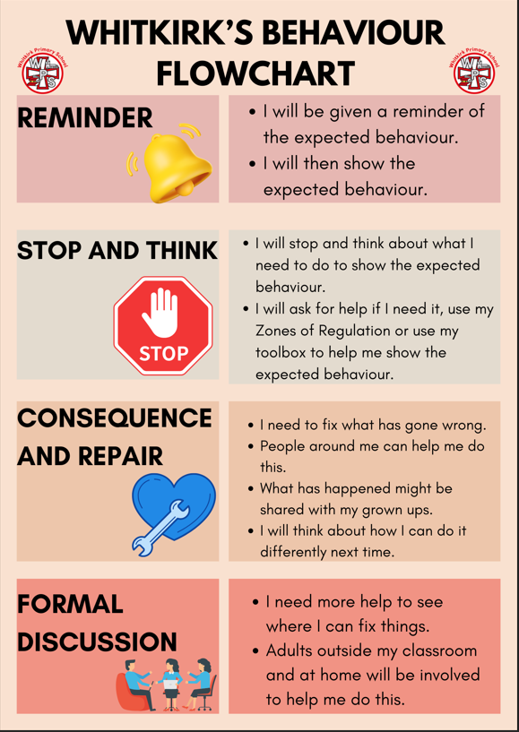

**Appendix 3- School Behaviour Flowchart (Staff Version)**

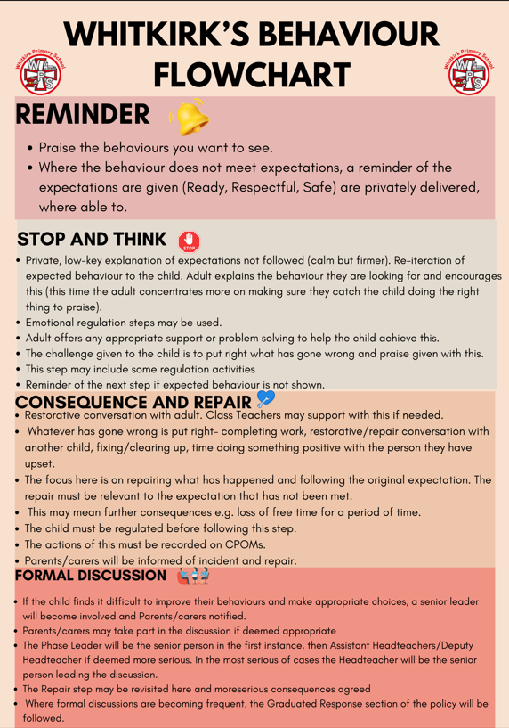

**Appendix 4 -Ready, Respectful, Safe School Poster**

**Appendix 5- Restorative Practice Poster**

**Appendix 5- Zones of Regulation**

At Whitkirk, we are use the Zones of Regulation throughout the whole school. We want to teach all of our children good coping and regulation strategies so they can help themselves when they experience anxiety and stress.

In the classroom, sometimes children panic when faced with a tricky learning problem or challenge. By teaching them how to cope with these feelings might make them better at tackling learning challenges and build better resilience so they don’t give up so easily when faced with difficulty. We want children at Whitkirk to grow into successful teenagers then adults. Teaching the children at a young age about managing their feelings will support them in later life so that they don’t turn to negative coping strategies which affect their mental and physical wellbeing.

We aim to help children to:

* Recognise when they are in the different Zones and learn how to change or stay in the Zone they are in
* Increase their emotional vocabulary so they can explain how they are feeling.
* Recognise when other people are in different Zones, thus developing better empathy.
* Develop an insight into what might make them move into the different Zones.
* Understand that emotions, sensory experiences such as lack of sleep or hunger and their environment might influence which Zone they are in.
* Develop problem-solving skills and resilience
* Identify a range of calming and alerting strategies that support them (known as their personal ‘toolkit’.

The Four Zones

Blue Zone: low level of arousal; not ready to learn; feels sad, sick, tired, bored, moving slowly.

Green Zone: calm state of alertness; optimal level to learn; feels happy, calm, feeling okay, focused.

Yellow Zone: heightened state of alertness; elevated emotions; has some control; feels frustrated, worried, silly/wiggly, excited, loss of some control.

Red Zone: heightened state of alertness and intense emotions; not an optimal level for learning; out of control; feels mad/angry, terrified, yelling/hitting, elated, out of control.

We will teach the children that everyone experiences all of the Zones. The Red and Yellow zones are not ‘bad’ or ‘naughty’ Zones. All of the Zones are expected at one time or another. We will show them that the Blue Zone, for example, is helpful when you are trying to fall asleep.

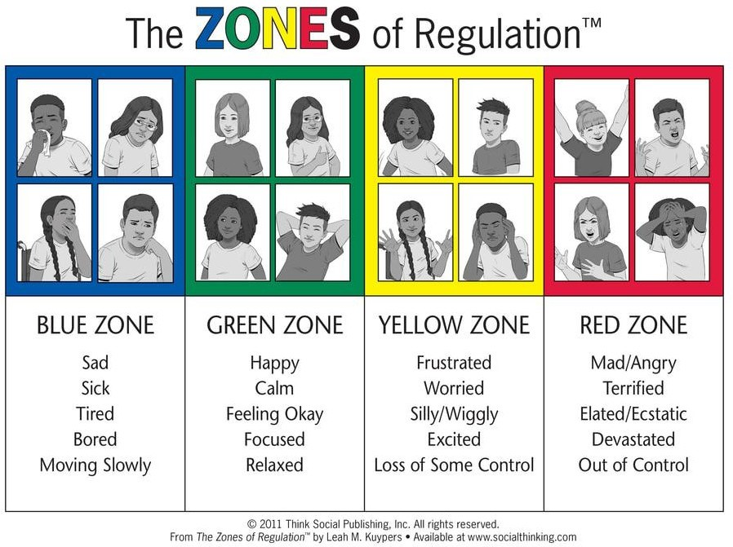

**Appendix 6- Glossary of terms**

|  |  |
| --- | --- |
| CPOMS | Child Protection Management System. This is an online software used by schools to monitor child protection incidents, as well as behaviour, health and safety (accidents) and well as SEND. |
| DfE | Department for Education. This is a [ministerial department](https://en.wikipedia.org/wiki/Departments_of_the_Government_of_the_United_Kingdom) of the government. It is responsible for education, (compulsory, further, and higher education),  [child protection](https://en.wikipedia.org/wiki/Child_protection), [child services](https://en.wikipedia.org/wiki/Child_services),  [apprenticeships](https://en.wikipedia.org/wiki/Apprenticeships_in_the_United_Kingdom), and wider skills in [England](https://en.wikipedia.org/wiki/England). |
| DSL | Designated Safeguarding Lead. This is a senior member of staff who takes the lead responsibility for safeguarding and child protection in school. |
| Dysregulation | Inability to to control or regulate one’s own emotional responses. |
| Fight or Flight | The fight-or-flight response, also known as the acute [stress response](https://www.verywellmind.com/what-is-a-stress-response-3145148), refers to the physiological reaction that occurs when in the presence of something mentally or physically terrifying. This response is triggered by the release of hormones that prepare your body to either stay and deal with a threat or to run away to safety. |
| LADO | Local Authority Designated Officer. The Local Authority Designated Officer (LADO) is the person who should be notified when it has been alleged that a professional or volunteer who works with children has behaved in a way that has harmed or may harm a child. |
| Physical Intervention | Physically moving a child to keep himself/herself safe and/or others safe. |
| SENCO | Special Educational Needs Coordinator. The school teacher who is responsible for assessing, planning and monitoring the progress of children with special educational needs and disabilities (SEND). |
| SENIT | Special Educational Needs Inclusion Team (Local Authority). The Special Educational Needs and Inclusion Team (SENIT) is a multidisciplinary team of specialist teachers, inclusion workers and project workers with expertise in early childhood development, and learning and cognition needs across all phases of education. |
| Virtual Headteacher | All local authorities in England are required to have a virtual school and a virtual school head to ensure that looked-after and previously looked-after children have the maximum opportunity to reach their full potential. The Children and Families Act 2014 requires local authorities in England to have a virtual school Head (VSH) who monitors looked after children, previously looked after children and those children with a social worker as if they were in one school, the virtual school. |